**Finger Stick GeneXpert HCV Point of Care Testing**

|  |  |
| --- | --- |
| **Step 1: Setting Up the GeneXpert Machine** | |
| 1. Ensure laptop and GeneXpert machine are connected 2. Turn on the GeneXpert machine **FIRST**. 3. Turn on the laptop **SECOND**. \*\* If you turn on the laptop first, the GeneXpert machine will not recognise the laptop. | |
| **Step 2: Logging into the GeneXpert Machine** | |
| 1. On the desktop is an icon titled “Cepheid”. Select this icon by double clicking. 2. Enter password “cphd” and press return. 3. The GeneXpert Software will open by itself. You may need to wait 10-20 seconds before you see the software appear. | |
| **Step 3: Database management tasks (Backup previous tests)** | |
|  | Once the program opens it will ask you if you wish to perform Database Management Tasks.  Select Yes. |
|  | The database backup screen will appear.  Select Proceed. |
|  | The database backup screen will appear.  Press Save to back up data  Please back up data in both the computer and the USB that is supplied with the laptop.  This USB will be used to send backup and archive data to The Kirby Institute as requested. |
|  | Once backup is complete you will see a message stating Backup Complete. |
| **Step 4: Check the Cartridge for Damage** | |
| C:\Users\Cfernandez\AppData\Local\Microsoft\Windows\Temporary Internet Files\Content.Word\DSC00248.jpg | Use one GeneXpert cartridge for each patient sample.  **IMPORTANT:** Cartridge must be used within 1 hour of opening the cartridge. |
|  | Check the cartridge to make sure it isn’t damaged.  Check the outside for damage.  Open the lid and check it is clean and clear.  If you see any debris, damage or crystals discard this cartridge and select another one for the test. |
| C:\Users\Cfernandez\AppData\Local\Microsoft\Windows\Temporary Internet Files\Content.Outlook\O7BGUI1R\IMG_9451.JPG | At the back of the cartridge is the PCR Tube/Optical Window.  **\*\*Do not touch this part of the cartridge.\*\***  If it is damaged discard this cartridge and select another one for the test. |
| **Step 5: Perform the Finger Prick and Collect Blood** | |
|  | You may need to massage the hand and lower part of the finger to maintain blood flow to the fingertip.  You can also encourage patients to warm their own hands by rubbing their hands together, shaking them and performing fist pumps.  Alternatively, you can apply a heat pack over the area, or place the finger under warm running water. |
|  | Position the hand palm-side up.  Select the least calloused fingertip of the ring, middle or index finger. You may use the thumb if it is the least calloused finger. |
|  | Use an alcohol swab to clean the participant’s finger.  Allow the finger to air dry. |
|  | Pick up a new sterile lancet. Show the lancet to the patient to reassure them that the lancet is new and unused.  Remove the yellow protective piece from the top of the lancet before using. |
|  | Place the lancet in the centre of the fingertip with the large yellow circle pointing away from the patient.  Hold the finger and firmly press the lancet against the finger when making the puncture.  Dispose of the lancet in a biohazard sharps container. |
|  | Wipe away the first drop of blood with a sterile gauze pad or cotton ball.  Keep the finger in a downward position and gently massage to maintain blood flow. |

|  |  |  |  |
| --- | --- | --- | --- |
| **Collecting Blood Sample** | | | |
|  | Hold the minivette at an angle so that the plunger is below the minivette tip and the blood filling the minivette easily.  Collect the blood drops using the capillary tip until the blood has reached the filter and the minivette is full.  **IMPORTANT:** You will need to minimise the air bubbles in the minivette during sample collection to ensure that the full volume of sample is collected. | | |
|  | Place a cotton ball on the participants’ finger once the minivette is full and ask them to hold it in place where the fingerstick was performed. | | |
|  | Place a band aid on the participant’s finger. | | |
| **Step 6: Place Minivette into Cartridge** | | | |
|  | Place minivette into the large sample opening.  The wings of the minivette tube should sit flush against the top of the cartridge cover to ensure that the sample is delivered to the bottom of the cartridge. | | |
|  | Press the plunger of the minivette. Make sure you hold onto the cartridge while doing this so that you don’t knock it over and spill the contents.  Close the lid of the cartridge.  **IMPORTANT:** Start the test immediately after adding the blood sample. | | |
| **Step 7: Dispose of the Minivette** |  | | |
|  | Remove the minivette and discard into a biohazard waste bin. | | |
| **CREATING A TEST USING A BARCODE SCANNER** | | | |
| **STEP 8: Load Patient Sample and Create a Test** |  | | |
| **P:\VHCRP\Hepatitis C\DARLO-C_1510\2.0  Study Tools\2.7  Manual of Operations\Cepheid information\5_blank home screen.PNG** | On the laptop, open the GeneXpert software if not already open.  Click on the Create Test button in the top left corner. | | |
| **Step 9: Enter Sample Details** | | | |
| P:\VHCRP\Hepatitis C\DARLO-C_1510\2.0  Study Tools\2.7  Manual of Operations\HCV Point of Care Manual and Flowchart\Cepheid Information and Resources\Images and Screenshots\Image_Barcode Scanner 5.PNG | A dialogue box will appear to enter sample details. At the bottom of this window, is an option to select Scan Cartridge Barcode.  Hold the scanner 10cm away from the cartridge barcode to scan the barcode. The machine will beep when the barcode is registered, and the cartridge information will be automatically populated in the dialogue box.  Enter the Sample ID and study visit:   * **Sample ID:** Screening ID (444-XXX) OR Subject ID (1510 – 5 Digit Site Number – 2 Digit Patient Number) * **Notes:** Enter the study visit   Once all the information is entered and is correct select Start Test. | | |
| **CREATING A TEST BY MANUAL DATA ENTRY** | | |
| **Step 8: Load Patient Sample and Create Test** | | |
| **P:\VHCRP\Hepatitis C\DARLO-C_1510\2.0  Study Tools\2.7  Manual of Operations\Cepheid information\5_blank home screen.PNG** | | On the laptop, open the GeneXpert software if not already open.  Click on the Create Test button in the top left corner. | |
| **Step 9: Enter Sample Details** | | | |
|  | | Enter the Sample ID, Serial number, assays and sample type.   * **Sample ID:** Screening ID (444-XXX) **OR** Subject ID (1510 – 5 Digit Site Number – 2 Digit Patient Number) * **Assay:** HCV Finger Stick * **Test Type:** Select ‘Specimen’ * **Notes:** Enter the study visit * **Cartridge Serial Number (S/N):** Enter the serial number last.   **No need to add information or make changes** **to**: Sample Type, Reagent Lot ID, expiration date, notes or select module.  **Please do not enter a past expired date in the expiration date field.**  **IMPORTANT:** Cartridges used in this study don’t have a barcode. When prompted to scan cartridge barcode press cancel instead and proceed to enter details manually as above.  Once all the information is entered and is correct select Start Test. | |

|  |  |  |  |
| --- | --- | --- | --- |
| **Step 10: Load Cartridge** | | | |
| Running assay  Assay finished  P:\VHCRP\Hepatitis C\DARLO-C_1510\2.0  Study Tools\2.7  Manual of Operations\Cepheid information\Cepheid machine, fingerstick and cartridge Photos\FL phone\Cepheid photos\photo.JPG | | The machine will select the module for you and indicate which to one to use by a green light.  Load the cartridge into the module marked with green blinking lights and push close the door.  The machine will perform and probe check.  Once the probe check is complete the test will begin. The time remaining for the test will be displayed on the laptop. | |
| **Step 11: Dispose of the Cartridge** | | | |
|  | | Once the test is complete remove the cartridge from the module and into a biohazard waste bin.  **\*\*Do NOT open the cartridge after use.\*\***  Return the module doors to the closed position.  **IMPORTANT:** Each module will perform the PCR reaction independently to the other modules. You can load samples at different timepoints. | |
| **Step 12: Reporting Results** | | | |
|  | | | Click on View Results button.  The result will be displayed below in the Test Result tab  If a sample has detected HCV RNA, you will need to record the quantity detected.  E.g. 1.13 E06 IU/ml. |
| You may encounter three types of problems in a test run:   * An **INVALID** result indicates that the sample was not properly processed, PCR was inhibited, or the sample was inadequate. * An **ERROR** result indicates that the Probe Check Control failed or maximum pressure limits were exceeded. * A **NO RESULT** indicates that insufficient data was collected. For example, the operator stopped a test that was in progress, a load error occurred, or the software was closed prematurely.   The Probe Check Control verify:   * If there is any missing Target Specific Reagent (TSR) and Enzyme Reagent (EZR) and Controls (IQS-H and IQS-L) beads, which contain all primers, probes, polymerase, dNTP and internal control template. * If there is an Incomplete bead reconstitution. * If there is an Incomplete PCR reaction tube fill. * If there is a probe degradation. | | | For a result with an error outcome, please record the error code in OpenClinica that applies to the sample.  In the event that the outcome of the test is indicated as a No Result, this should be recorded as an error in OpenClinica. |
|  | | | The errors code can be found by selecting the Errors tab on the view results screen.  E.g. Error 2005  Enter this error code in OpenClinica.  A full list of error numbers and their corresponding message and causes and solutions can be found in [Appendix 1.](#_Appendix_1_–) |
|  | | | Should you want to find out more information about an error code you can search the Cepheid POC machine manual.  The manual will be saved on the computer desktop as Gx Dx Operator Manual v4.7b ENGLISH.  Double click on the icon to open the manual. Use the CONTROL F function to open a ‘find’ window. Type in the code number as shown in the error screen and the function will find the relevant error code within the document. |
| **Step 13: Turning off the machine** | | | |
| **P:\VHCRP\Hepatitis C\DARLO-C_1510\2.0  Study Tools\2.7  Manual of Operations\Cepheid information\Cepheid machine, fingerstick and cartridge Photos\POC turrn on off.jpg** | | | Once you have completed all tests and completed archiving.  Turn off the laptop **first** and the GeneXpert machine **second**. |
| **Step 14: Archiving** | | | |
| **P:\VHCRP\Hepatitis C\DARLO-C_1510\2.0  Study Tools\2.7  Manual of Operations\2.7.5 Cepheid Information and Resources\Images and Screenshots\Screenshot 9_View Results.PNG**  **P:\VHCRP\Hepatitis C\DARLO-C_1510\2.0  Study Tools\2.7  Manual of Operations\2.7.5 Cepheid Information and Resources\Images and Screenshots\Screenshot 16_Archiving_A Test Selected for Archiving.PNG**  **P:\VHCRP\Hepatitis C\DARLO-C_1510\2.0  Study Tools\2.7  Manual of Operations\2.7.5 Cepheid Information and Resources\Images and Screenshots\Screenshot 17_Archiving_Confirmation that a Test has been Selected.PNG**  **P:\VHCRP\Hepatitis C\DARLO-C_1510\2.0  Study Tools\2.7  Manual of Operations\2.7.5 Cepheid Information and Resources\Images and Screenshots\Screenshot 18_Archiving_Selecting Location for Archiving.PNG** | | | Navigate to the Data Management menu and click on Archive Test.  Select the test(s) to be archived by clicking the checkbox(es) on the first column. Click OK.  A dialog box will appear to confirm this request. Click Proceed.  A dialog box will appear to save the tests. Locate and select the folder where you want to save the archived test(s), type the file name (e.g. Date (YYMMDD)\_Screening or Participant ID), and then click Save.  Repeat this process to save a copy of the test onto the usb.  Once the test(s) have been archived, a message will be displayed to show that this has been performed. Click OK. |
| **Step 15: Saving and printing a PDF report** | | | |
| **P:\VHCRP\Hepatitis C\DARLO-C_1510\2.0  Study Tools\2.7  Manual of Operations\2.7.5 Cepheid Information and Resources\Images and Screenshots\Screenshot 9_View Results.PNG**  **P:\VHCRP\Hepatitis C\DARLO-C_1510\2.0  Study Tools\2.7  Manual of Operations\2.7.5 Cepheid Information and Resources\Images and Screenshots\Screenshot 20_Saving Report_Specimen Report Selection Criteria Box.PNG**  **P:\VHCRP\Hepatitis C\DARLO-C_1510\2.0  Study Tools\2.7  Manual of Operations\2.7.5 Cepheid Information and Resources\Images and Screenshots\Screenshot 21_Saving Report_A PDF of Specimen Report.PNG**  **P:\VHCRP\Hepatitis C\DARLO-C_1510\2.0  Study Tools\2.7  Manual of Operations\2.7.5 Cepheid Information and Resources\Images and Screenshots\Screenshot 22_Saving Report_Selecting a Location to Save Report 1.PNG** | | | Navigate to the Reports menu and click Specimen Report.  A dialog box will appear to assist with finding the report. Enter criteria for date range and/or sample ID. Click on Preview PDF.  A pdf of the report will appear. To save a copy of the report, click File and Save As. A dialog box will appear to save the report(s). Locate and select the folder where you want to save the report, type the file name (e.g. Date (YYMMDD)\_Screening or Participant ID), and then click Save. |
| **Step 16: Maintenance** | | | |
|  | | | There are daily and weekly maintenance jobs that are needed to keep the machine functioning properly.  The daily maintenance tasks only need to be completed on days in which you use the machine. Please indicate on the maintenance log if a machine was not used on a certain day.  These need to be recorded in the Maintenance Log which can be found in [Appendix 2](#_Appendix_2_–). |
| **P:\VHCRP\Hepatitis C\DARLO-C_1510\2.0  Study Tools\2.7  Manual of Operations\Cepheid information\Cepheid machine, fingerstick and cartridge Photos\Cepheid machine.JPGC:\Users\Jvandyk\Desktop\kimwipes.jpg** | | | **Daily Maintenance**   1. Clean work area with diluted bleach or 70% ethanol with Kim wipes. Clean off any excess bleach with 70% ethanol. 2. Close all module doors. 3. Discard used cartridges. 4. Fill out the maintenance log found in [Appendix 2](#_Appendix_2.).   **IMPORTANT:** Do not leave the bleach on the machine for more than 2min. |
| **P:\VHCRP\Hepatitis C\DARLO-C_1510\2.0  Study Tools\2.7  Manual of Operations\Cepheid information\Cepheid machine, fingerstick and cartridge Photos\POC turrn on off.jpg** | | | **Weekly Maintenance**   1. Power down the GeneXpert instrument. 2. Power down the GeneXpert computer. 3. Fill out the maintenance log found in [Appendix 2](#_Appendix_2.). |
| **C:\Users\Jvandyk\Desktop\kimwipes.jpg** | | | **Quarterly Maintenance – Clean instrument surfaces**   1. Clean instrument surfaces with 10% bleach followed by 70% ethanol. 2. Fill out the maintenance log found in [Appendix 2](#_Appendix_2.).   Do not allow the bleach to remain on surfaces for more than 2 minutes. |
|  | | | **Quarterly Maintenance – Clean plunger rods and cartridge bays**   1. Ensure there are no cartridges left in the bays. 2. Select Plunger Rod maintenance from the maintenance menu. 3. Select Clean. |
|  | | | 1. The plunger rod will lower down for cleaning 2. Use a lint-free wipe to wipe the plunger rod with bleach 1/10 dilution. 3. Use the same lint free wipe to wipe the walls, ceiling, corners and edges of the cartridge bay. 4. Leave bleach on the plunger 30 seconds before cleaning it off. **Do not** leave the bleach on the plunger rod for more than 2 minutes. |
|  | | | 1. After the plunger rod and cartridge bay have been cleaned return to the plunger maintenance dialog box. 2. Select move up. 3. Plunger rod will return to the resting position. 4. Close the door. 5. Fill out the maintenance log found in [Appendix 2](#_Appendix_2.). |
| **Trouble shooting** | | | |
| Clinical Project Coordinator  Kirby Institute  Email: [darlo-c@kirby.unsw.edu.au](mailto:darlo-c@kirby.unsw.edu.au)  Phone: (02) 9385 9668 | Ms Jomar Rivas, Application Specialist  Email: [Jomar.Rivas@cepheid.com](mailto:Jomar.Rivas@cepheid.com)  Mr Chris Hum, Application Specialist  Email: [Chris.Hum@cepheid.com](mailto:Chris.Hum@cepheid.com)  Phone: 1800 130 821  Please Cc your Clinical Project Coordinator into any correspondence sent to Cepheid. | | |

**Appendices**

## Appendix 1 – Error messages

**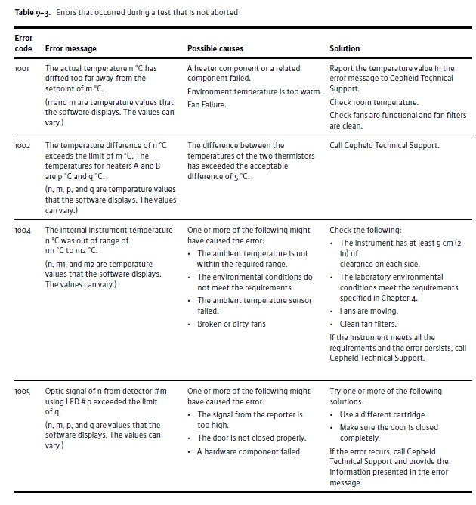**

**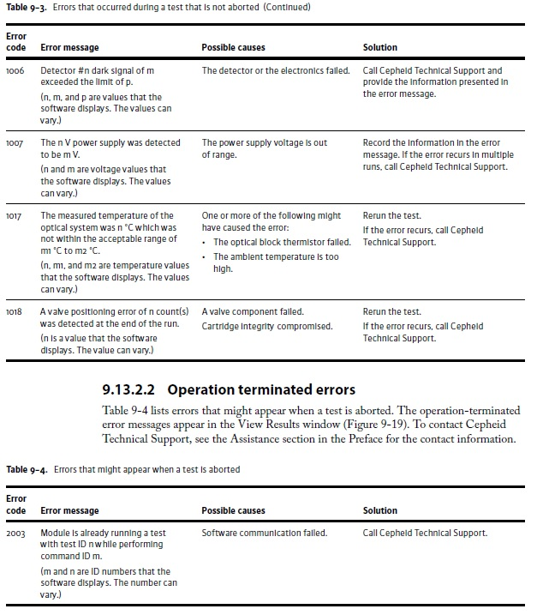** **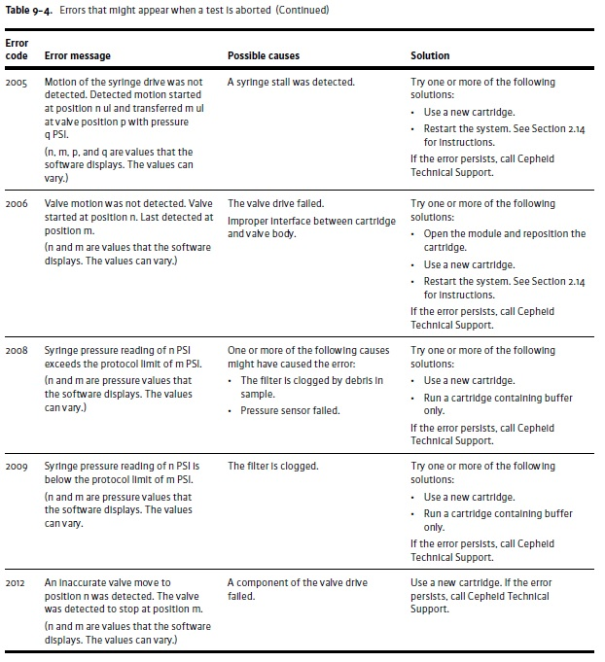** 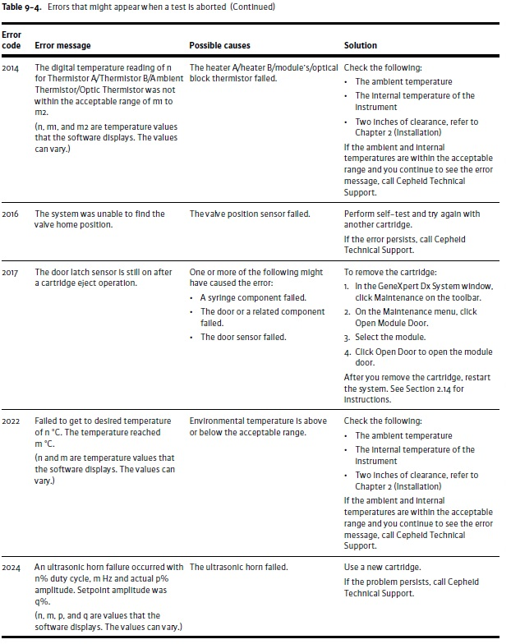

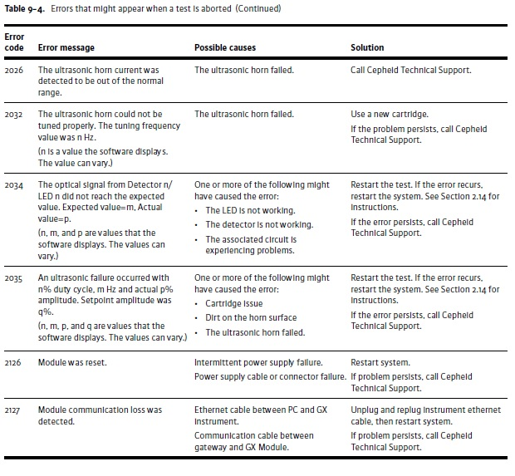 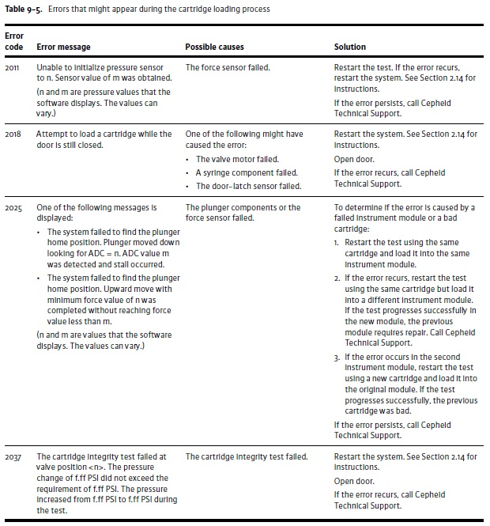

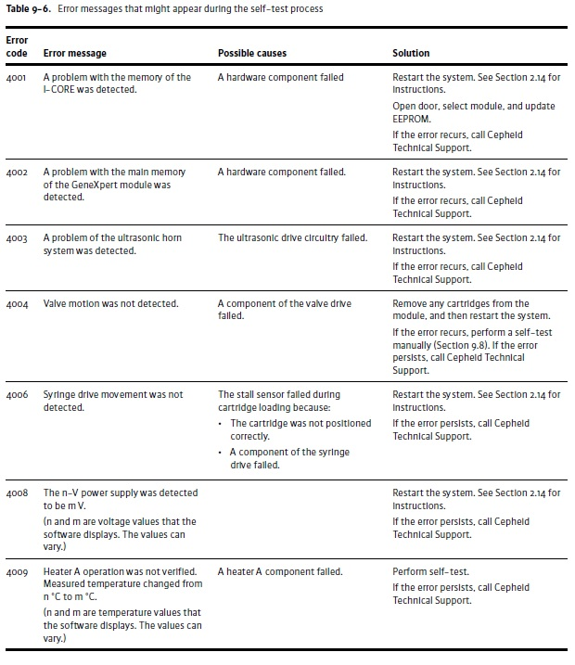 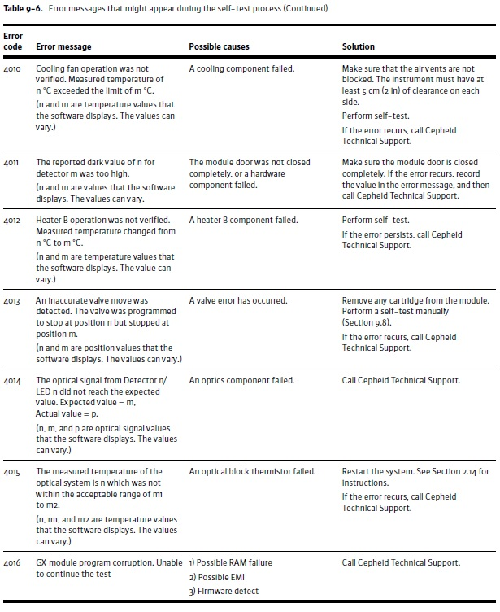 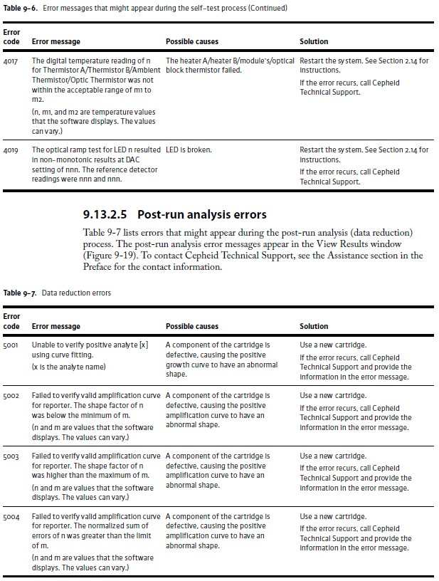 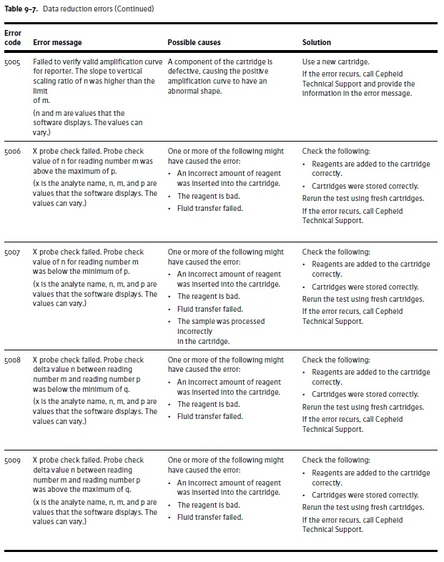 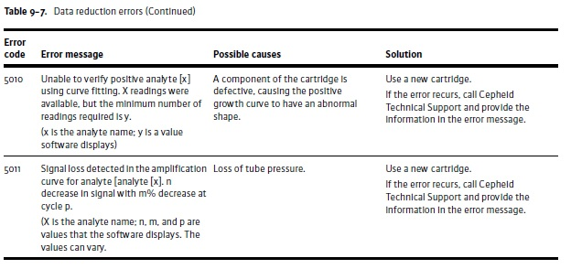

## Appendix 2 – Maintenance Logs.

**GeneXpert System Maintenance Log**

Month and Year: \_\_\_\_\_\_\_\_\_\_\_\_\_\_\_\_\_\_\_\_\_\_\_\_\_

Name of Institution: \_\_\_\_\_\_\_\_\_\_\_\_\_\_\_\_\_\_\_

GeneXpert Serial Number: \_\_\_\_\_\_\_\_\_\_\_\_\_\_\_\_\_\_\_\_\_\_\_\_

|  |  |  |  |  |  |  |  |  |  |  |  |  |  |  |  |  |  |  |  |  |  |  |  |  |  |  |  |  |  |  |  |
| --- | --- | --- | --- | --- | --- | --- | --- | --- | --- | --- | --- | --- | --- | --- | --- | --- | --- | --- | --- | --- | --- | --- | --- | --- | --- | --- | --- | --- | --- | --- | --- |
|  | 1 | 2 | 3 | 4 | 5 | 6 | 7 | 8 | 9 | 10 | 11 | 12 | 13 | 14 | 15 | 16 | 17 | 18 | 19 | 20 | 21 | 22 | 23 | 24 | 25 | 26 | 27 | 28 | 29 | 30 | 31 |
| **Daily Maintenance** |  | | | | | | | | | | | | | | | | | | | | | | | | | | | | | | |
| **Clean work area** |  |  |  |  |  |  |  |  |  |  |  |  |  |  |  |  |  |  |  |  |  |  |  |  |  |  |  |  |  |  |  |
| **Close all module doors** |  |  |  |  |  |  |  |  |  |  |  |  |  |  |  |  |  |  |  |  |  |  |  |  |  |  |  |  |  |  |  |
| **Discard used cartridges** |  |  |  |  |  |  |  |  |  |  |  |  |  |  |  |  |  |  |  |  |  |  |  |  |  |  |  |  |  |  |  |
| **Technicians Initials** |  |  |  |  |  |  |  |  |  |  |  |  |  |  |  |  |  |  |  |  |  |  |  |  |  |  |  |  |  |  |  |
| **Weekly Maintenance** |  | | | | | | | | | | | | | | | | | | | | | | | | | | | | | | |
| **Power down the GeneXpert instrument** |  | | | | | | |  | | | | | | |  | | | | | | |  | | | | | | |  | | |
| **Power down the GeneXpert Computer** |  | | | | | | |  | | | | | | |  | | | | | | |  | | | | | | |  | | |
| **Technicians Initials** |  | | | | | | |  | | | | | | |  | | | | | | |  | | | | | | |  | | |

**GeneXpert System Maintenance Log**

Year: \_\_\_\_\_\_\_\_\_\_\_\_\_\_\_\_\_\_\_\_\_\_\_\_\_\_\_\_\_\_\_\_\_\_

Name of Institution: \_\_\_\_\_\_\_\_\_\_\_\_\_\_\_\_\_\_\_

GeneXpert Serial Number: \_\_\_\_\_\_\_\_\_\_\_\_\_\_\_\_\_\_\_\_\_\_\_\_

|  |  |  |  |  |  |  |  |  |  |  |  |  |
| --- | --- | --- | --- | --- | --- | --- | --- | --- | --- | --- | --- | --- |
| **Month** | **Jan** | **Feb** | **Mar** | **Apr** | **May** | **June** | **Jul** | **Aug** | **Sep** | **Oct** | **Nov** | **Dec** |
| **Quarterly Maintenance** |  | | | | | | | | | | | |
| **Clean plunger rod and cartridge bays** |  |  |  |  |  |  |  |  |  |  |  |  |
| **Clean instrument surfaces** |  |  |  |  |  |  |  |  |  |  |  |  |
| **Technicians Initials** |  |  |  |  |  |  |  |  |  |  |  |  |